What is CYIT?
Learning Opportunities @ CYIT

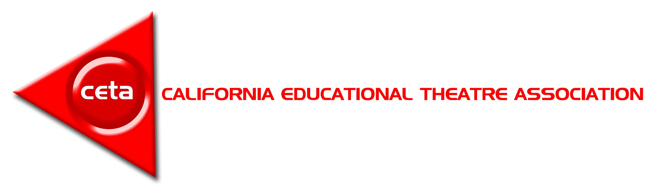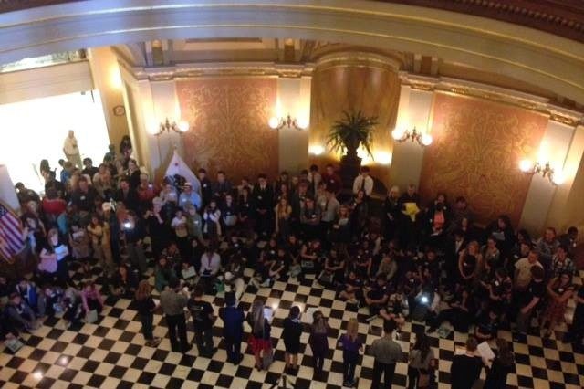CYIT is a celebratory day honoring theatre students throughout CA.
CYIT
2017
Youth in Theatre Day!
March 14, 2017 Sacramento, CA
California
CYIT Activities:

Opening Ceremony:

Participants sing “There’s No Business like Show Business” on the Capitol steps!
Selected Student Performances

in the Capitol Rotunda!
•Advocacy for the Arts
•Statewide recognition for your school
•Seeing CA legislation in action
•Being honored by the
L.T Governor’s Oﬃce
•Capitol visits
•Career opportunities for which Theatre is honored
•Student Accountability
•Workshops led by Sacramento Theatre Company professionals
•Common Core Standards in Action.
•Speaking with Legislators on behalf of theatre teacher & students

Meet & Greet

with Legislators!
Advocacy Workshops for teachers & students!
REGISTRATION INFO

Register Online @
Cetoweb.org
12/10/2016 -­‐ 2/22/2017
$30 per person*
*CYIT Scholarships are available through CETA’s Past Presidents Council, DTASC, & CA Thespian auditions at Fall 2016 North/ South Leadership Conferences. More Scholarship info available at Cetoweb.org

Pay online via Paypal or by check made payable to CETA
Connect with CETA Online!

/CATheatreEd @CATheatre
@CAEducationalTheatre

You must meet one of the following criteria:
How Can I perform at CYIT 2017?

COLLEGE STUDENTS:
Your performance piece received an award at the most recent KC/ ACTF Festival.

HIGH SCHOOL STUDENTS:
- Are a chosen representative of Comedy Sportz LA, San Jose, Sacramento, or Camp Bravo.
- “The Most Outstanding “ winner at your High School competition.
(H.S Competition where the Prize is a performance opportunity at CYIT)

OR if your performance piece:
• Received an award at any theatre festival in the state of CA during the present academic year.
• Advanced to the Finals Round at the Bob Smart Festival, Sacramento , Role About and/ or Fullerton High School Festival.
• Advanced to the Semiﬁnals Round at the DTASC Festivals and/or the English Speaking Union Shakespeare Competition.
• Auditioned successfully for the CA State Thespians CYIT Auditions, passed the Trinity School of Drama America & LAMDA examinations, performed with the Bakersﬁeld College Kern Shakespeare Festival, or qualiﬁed for a British Arts Award.

MIDDLE SCHOOL STUDENTS:
Your performance piece received an award at the most recent CETA Northern Middle School Festival or DTASC Festivals.

ELEMENTARY SCHOOL STUDENTS:
You are sponsored by your teacher & have a well-­‐rehearsed performance piece.

