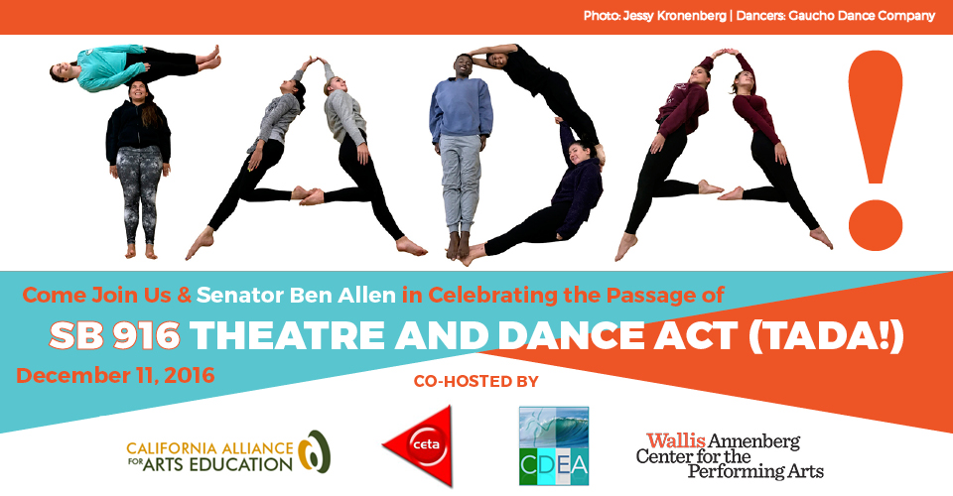

SB 916 (TADA!) Celebration
When: Sunday, December 11, 2016 @ 11am
Where: Wallis Annenberg Center for the Performing Arts, Beverly Hills

Register: https://sb916tadacelebration.eventbrite.com

Please join the California Alliance for Arts Education, California Dance Education Association, California Educational Theatre Association, and the Wallis Annenberg Center for the Performing Arts on December 11th at The Wallis as we celebrate the passage of SB 916, the Theatre and Dance Act (TADA!), and recognize the leadership of Senator Ben Allen in guiding its passage.
The recognition celebration and press event will be held from 11am-12pm, immediately followed from 12-2pm by Dance Sundays hosted by The Wallis, featuring a free hip-hop dance class for people of all ages.
RSVP to attend today! https://sb916tadacelebration.eventbrite.com
SB 916 was buoyed by the support of Annette Bening, the California Teachers Association, the California Federation of Teachers, and a multitude of organizations and individuals across the state.
We look forward to seeing you on December 11th!

