DTASC 100
THE DTASC CENTENNIAL CELEBRATION

Join us as we celebrate 100 years of outstanding theatrical achievement by middle and high school students from all over Southern California.

Since 1920, DTASC has fostered and celebrated student performance and design, creating an opportunity for educators and students alike to learn from each other. These bi-annual competitions have brought together dozens of schools, hundreds of educators and thousands of students, many of whom have gone on to successful careers in the theatre, television and film industries.

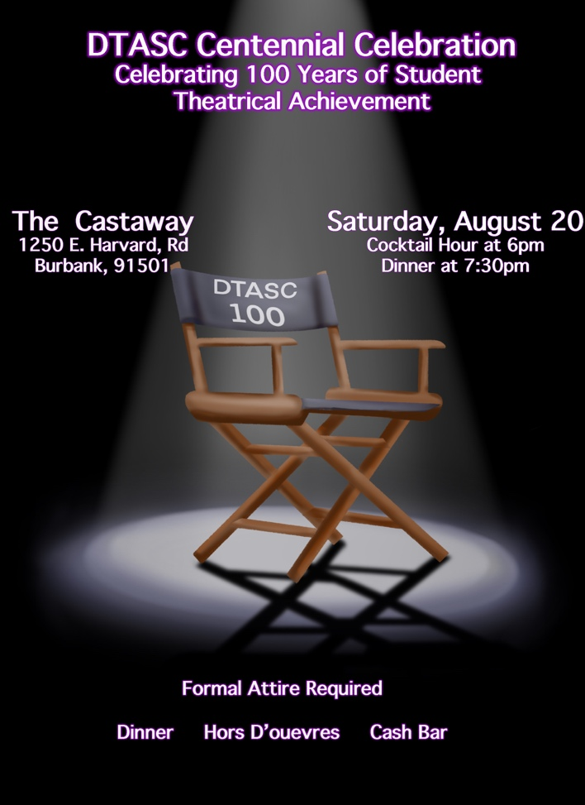

Tickets are $85 if you RSVP before April 23 (the date of this year’s Varsity Shakespeare Festival) and $100 between April 26 and August 1.

Check back soon for links to RSVP to join us for the celebration!

If you would like to volunteer to be a part of one of the committees planning the celebration, please email Roger Graziani

